EXPERIMENT 3- STAR TOPOLOGY

- LAYOUT:
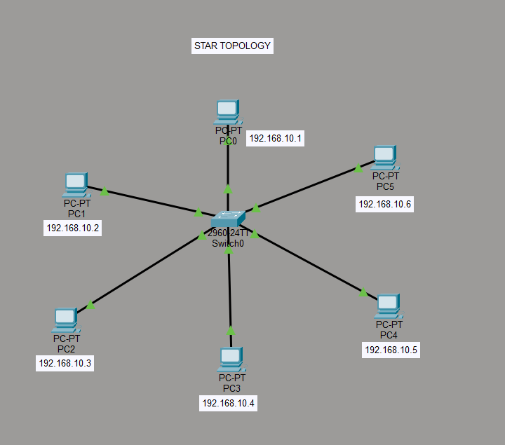

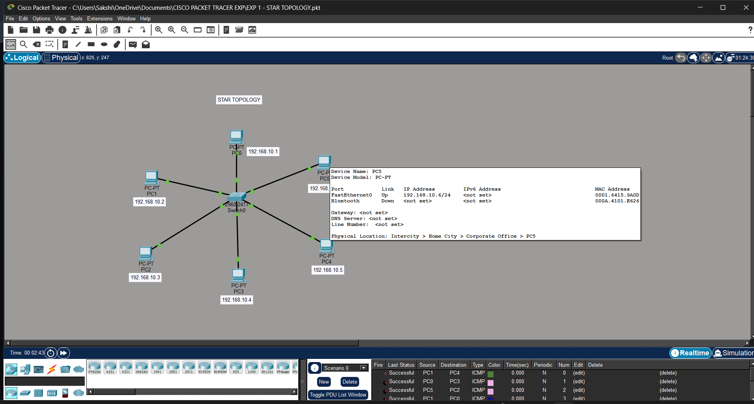

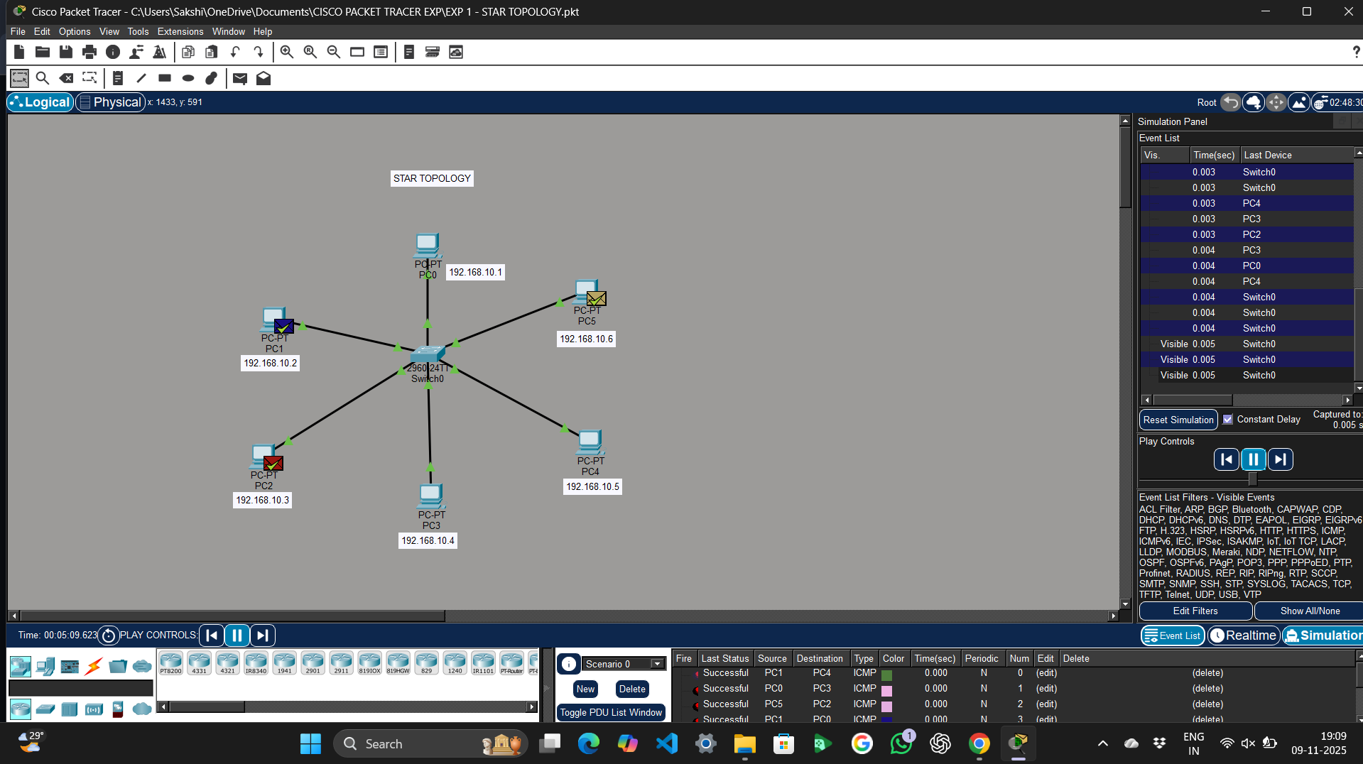

- IP ADDRESSES FOR END DEVICES:
1. PC0- 192.168.10.1
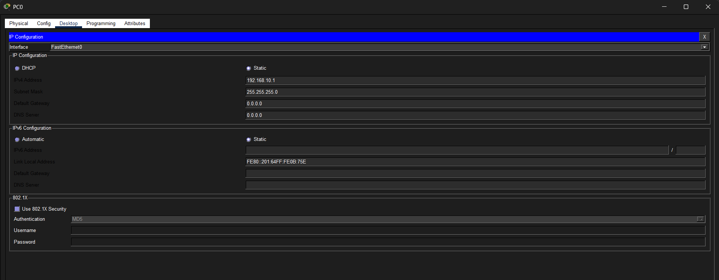

2. PC1- 192.168.10.2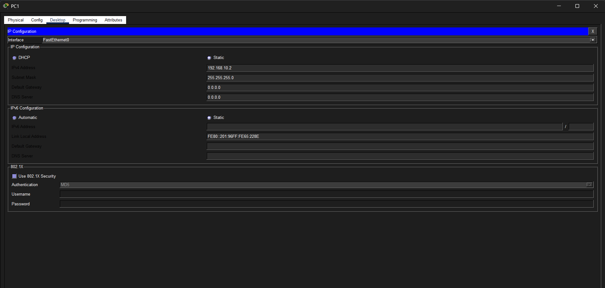

3. PC2- 192.168.10.3
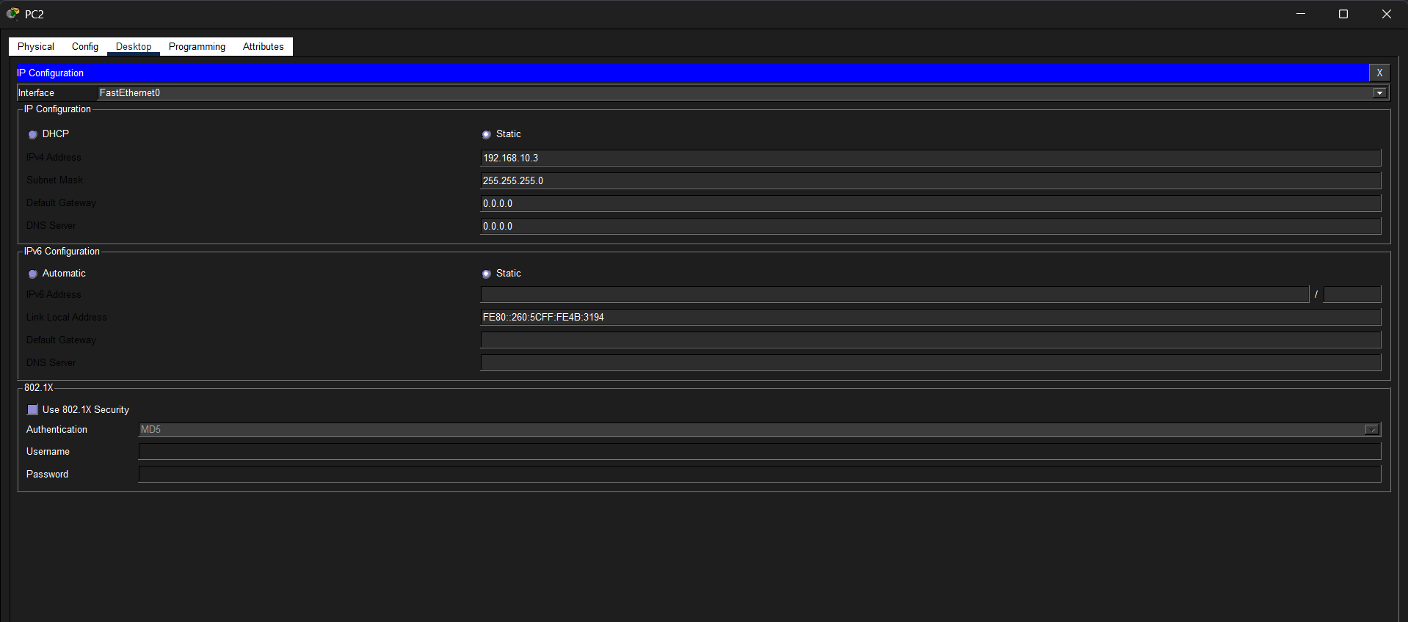
4. PC3- 192.168.10.4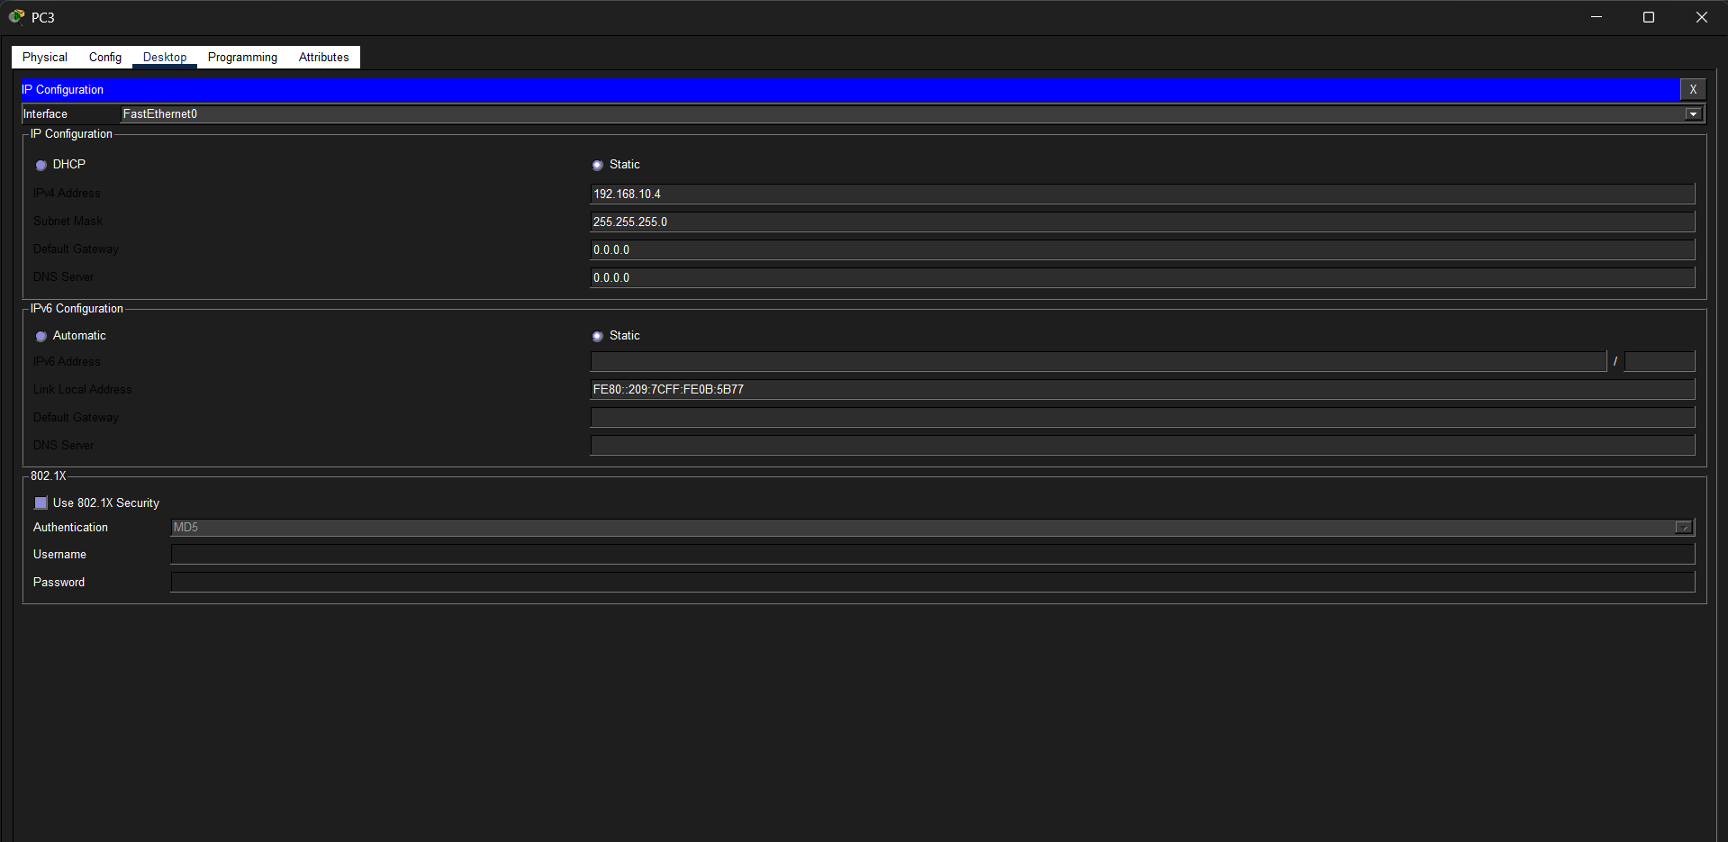
5. PC4- 192.168.10.5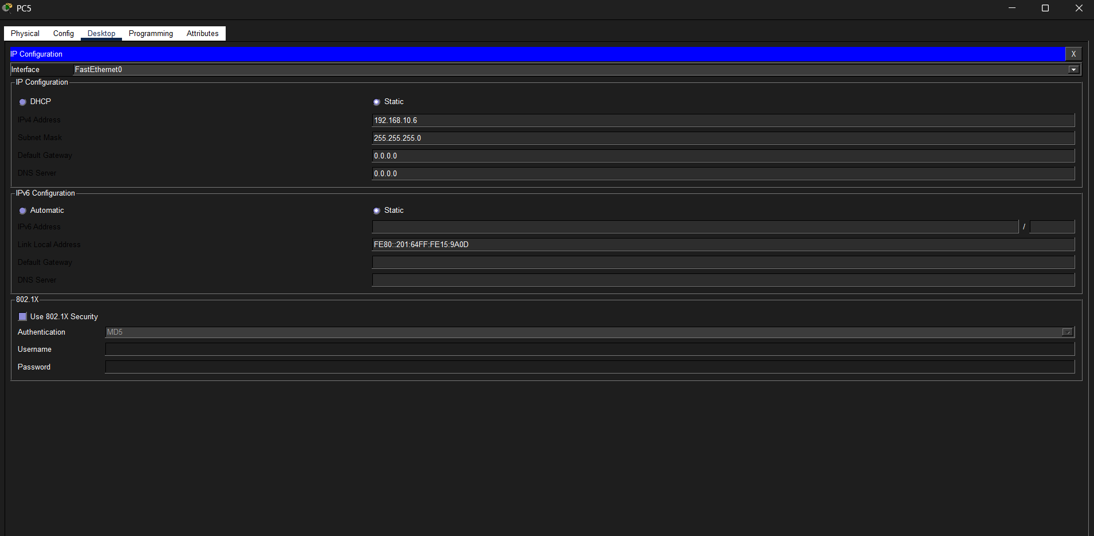 6. PC5- 192.168.10.6